Blackjack Handling System – GUI Mock-Ups
Group 2

Login Screen GUI
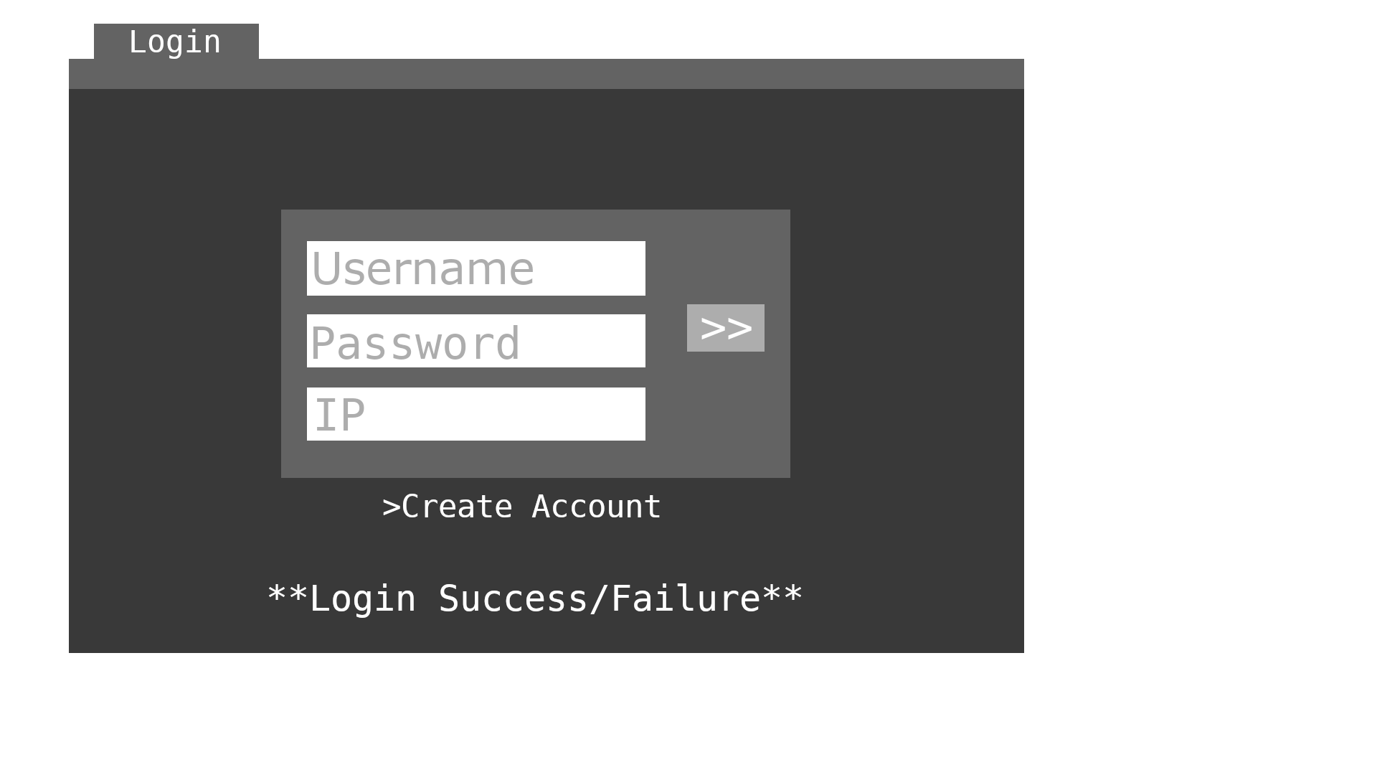

The outline of the login screen design is the most bare of the GUI screens, and will primarily be used to facilitate the authentication of existing user account logins as well as creation of new user accounts.

Existing users will be required to enter the three fields above to properly connect from their client to the Blackjack server program.

In the event of account creation, the login screen would intake the same information for setting up a new user account.

Lobby Screen GUI
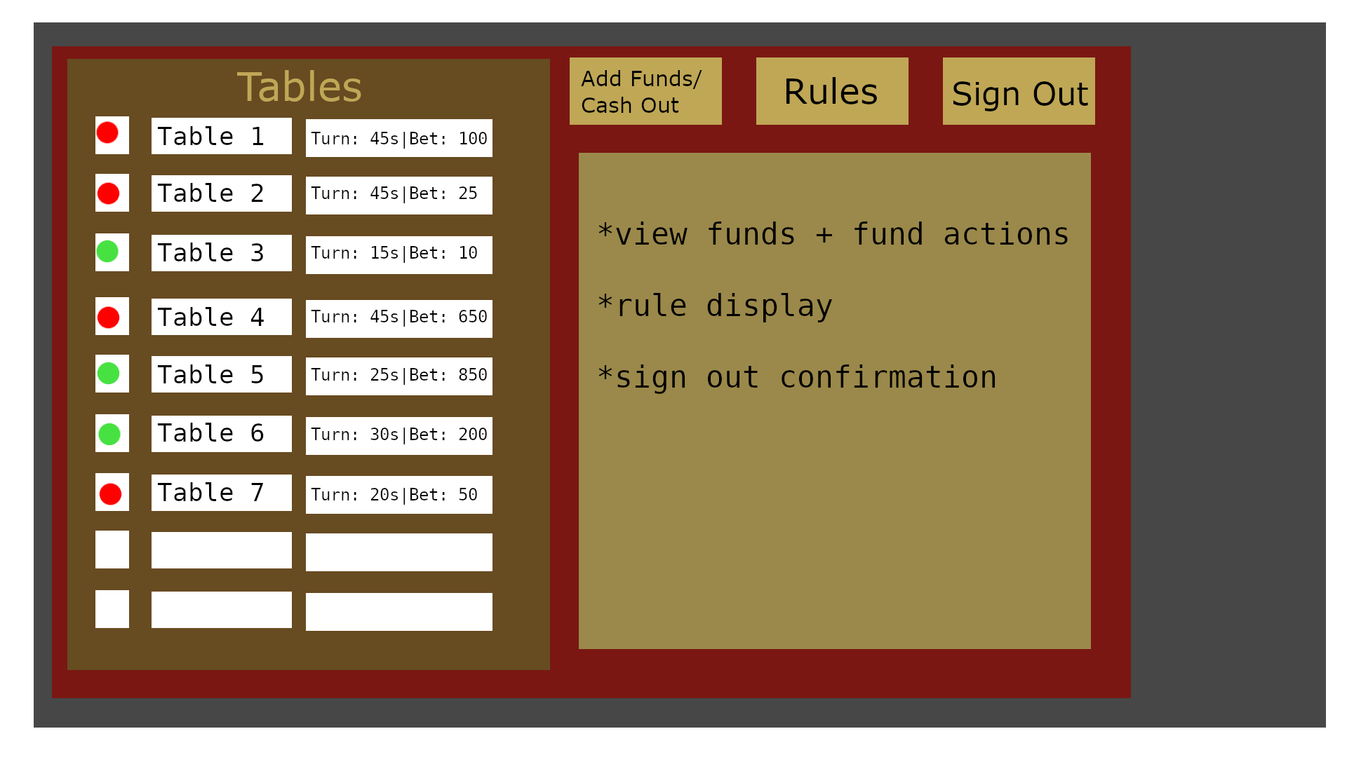
The lobby screen will provide an overview for regular player users to access a list of existing tables to play at, accompanied by the relevant details like table parameters for turn time/minimum bets as well as availability. The player users may also access settings or other resources such as actions for their balance, viewing the rules of blackjack for review, and signing out.

Tentatively, the mock-up shows the right-side viewable space with bullet points for the functionality provided by the upper GUI elements. This will be populated by the proper screens via panels.

Table Screen GUI (differentiated by user type)

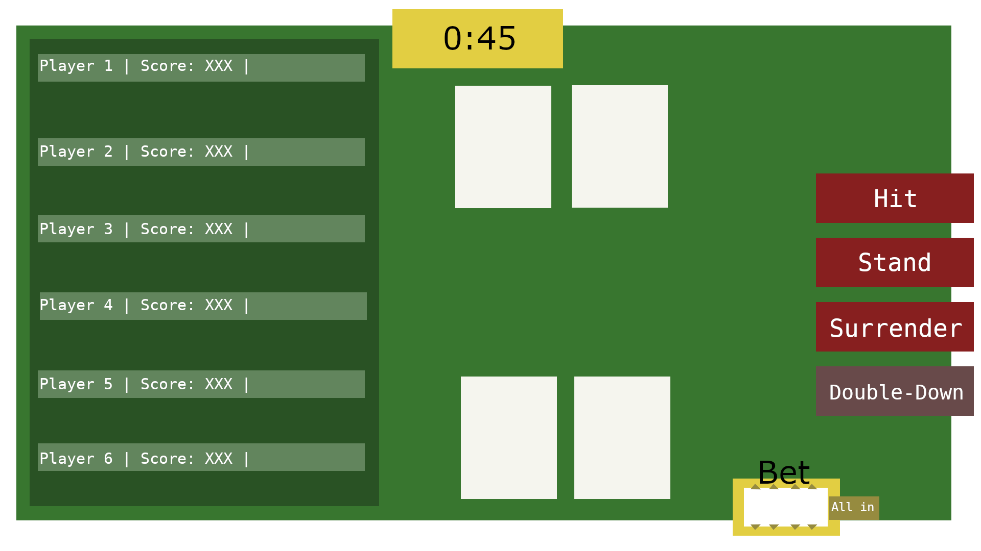

The table screen will be the primary interfacing area for the Blackjack gameplay, and will be largely similar between the player and dealer users with the exception of the action UI elements. Users will have access to their own hands and bets, as well as viewing the status, score, and roster of players within the table. The dealer of the table will view their own set of actions appropriate to the context of the game phase and events, such as dealing, running initial bets, and providing notice for the table dissolution after the next round if they log out.

The organization of the table roster will function as a real-life blackjack table does, with the top-most player being the first to enter the table and so on. This provides the turn order for dealing cards.

While the current mock-up shows the dealer hand at the top and the player hand at the bottom holding two cards, the region for the hand will ideally scale appropriately to accommodate as many cards needed within a given turn.

The bet region on the side of the user hand will be an incremental value for the user to set their bet.

As illustrated by the differentiated color in the Double-Down action, users will have a clear view of what actions are unavailable and ready based on the rules and logic of the game.

